**WRES1102/WIC2003**

Tutorial 1a

1. Write VHDL code for the figure given in the lecture. Print screen the RTL view
2. Design and proof the Full Adder design in Figure 1. Then, write the VHDL code for the full adder.

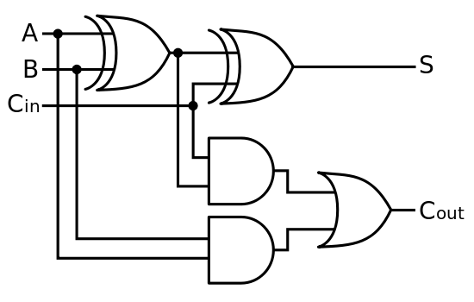

Figure 1: Full Adder